protypes

A prototype is a simulation of how a finished product will work. It allows product teams to test the usability and feasibility of their designs. A prototype is a draft version of a product that allows you to explore your ideas and show the intention behind a feature or the overall design concept to users before investing time and money into development. A prototype can be anything from paper drawings (low-fidelity) to something that allows click-through of a few pieces of content to a fully functioning site (high-fidelity).

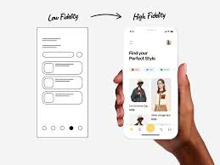Types of prototypes

* **Low-fidelity prototypes** are often paper-based and do not allow user interactions.  They range from a series of hand-drawn mock-ups to printouts.  In theory, low-fidelity sketches are quicker to create. Low-fidelity prototypes are helpful in enabling early visualization of alternative design solutions, which helps provoke innovation and improvement. An additional advantage to this approach is that when using rough sketches, users may feel more comfortable suggesting changes.

This is the initial view of a future site/platform/application. The testing of this type of prototype is carried out at an early stage of the design process to confirm that the concept of the product is correct. It is also a good way to ask users about heir vision of the product, certain block, or flow.

**Advantages of using low fidelity prototypes:**

* no need to spend a lot of time on prototyping;
* more opportunities to edit the prototype, as it will be easier and won’t take a lot of time for change at this stage;
* make it clear whether the concept of your project is clear to users;
* low-fidelity prototypes put less pressure on users. They can feel more relaxed and express their views in more detail;

Major mistakes:

* it is better not to use color for low fidelity prototypes. It will distract user attention. So, you risk wasting your time on doubts while choosing and discussing the palette;
* do not detail the prototype, the concept is your priority
* it is important to test prototypes with more than 7 people. This way the conclusions about the concept will be more objective and detailed.

Who is responsible for the prototype creation:

* the intermediate stage of the design will be available for stakeholders, so they will not expect the complete design immediately;
* a good understanding of the product and users.

High Fidelity prototypes

**High-fidelity prototypes** are computer-based, and usually allow realistic (mouse-keyboard) user interactions. High-fidelity prototypes take you as close as possible to a true representation of the user interface. High-fidelity prototypes are assumed to be much more effective in collecting true human performance data (e.g., time to complete a task), and in demonstrating actual products to clients, management, and others.High fidelity prototype is tested on users to check whether the interface is intuitive, whether they study hypotheses, test design for compliance with accessi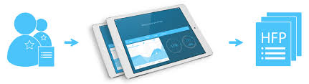bility requirements for people with different types of visual impairment (sometimes it calls “Accessibility testing”).After testing the high fidelity prototype, the results are approved by the customer/product owner and then transferred to the development.

Benefits of using high fidelity prototypes:

* you can test not only the functionality but also UI components — menus, filters, input fields, graphic elements (icons, photos, illustrations, animation)
* possibility to get more detailed conclusions about the certain site due to the high accuracy of prototypes
* ability to test all current hypotheses

Main mistakes:

* you don’t have to help users by telling them how to use the site. Let them make their own decisions. Your task is to observe, and then understand why they made such a choice
* you cannot come for testing unprepared. You should always have a list of questions that you may ask users after testing
* you shouldn’t give users a site with the task «click something on the site and say what you don’t like». All flows for testing need to be carefully worked out. It is also important to describe the target audience for a certain flow and problems that should be solved by the users on the site.